Capstone Project Phase B
24-2-D-26

Software Engineering Department
Braude College



Supervisor:
Alexander Keselman

Authors:
Chay Fadida 318302783
Tomer Lazarovitch 316377100

GitHub:
https://github.com/ChayFadida/AIFinancialAdv



Table of Contents
1. Abstract 3
2. Introduction 4
3. Background: 4
3.1 Stock Market Data API 4
3.2 LLM Model (Large Language Model) 5
3.3 Crew AI 5
3.4 FastAPI 6
3.5 React 6
3.6 MongoDB 7
3.7 Material-UI 7
3.8 Express 7
4. Research process: 8
4.1.2 System Design 8
4.1.3 Feature Implementation 8
4.2 challenges and solutions 9
4.3 Product 10
4.3.1 general scheme 10
4.3.2 use case 11
4.3.3 Activity diagram 12
4.3.4 package diagram 13
14
4.3 Results and conclusions 14
4.3.1 Phase A goals and Outcome 15
4.3.2 Challenges and decision-making considerations 16
4.3.3 Lessons learned 17
4.4 Testing process 17
4.4.1 Results and conclusions 21
5. User guide: 22
5.1 Nominal usage scenarios 22
5.1.1 Register and log in 22
5.1.2 Dashboard 23
5.1.3 My news 24
5.1.4 Recommendation 25
5.1.5 Chatbot 27
5.1.6 About 27
5.1.7 FAQ 28
5.1.8 Contact 29
5.1.9 Edit profile 29
6. Maintenance guide: 30
6.1 Operation Instructions: 30
6.1.1 Install Ollama 30
6.1.3 Install Python dependencies 31
6.1.4 Install dependencies for the API 31
6.1.4 Install dependencies for the client 31
6.1.5 Configure Environment Files 31
6.1.6 Run the AI integration service 31
6.1.7 Run the API server 31
6.1.8 Run the client application 32
7. Conclusions: 32
8. References: 32

1. Abstract

In today's financial landscape, the stock market remains a lucrative but complex arena for investment, particularly for individuals without financial expertise.
The primary challenge for these individuals is the high cost and often inaccessible nature of professional financial advice, coupled with the overwhelming array of investment choices.
Our project seeks to address these barriers by developing an innovative web application that combines artificial intelligence with advanced analytics to offer personalized stock investment advice. The proposed AI financial advisor will leverage two distinct analytical approaches:
the evaluation of quarterly financial reports and the analysis of individual stocks by it’s latest news.
By integrating these methodologies through a sophisticated AI framework, our system aims to democratize stock market investments, making them more accessible to non-experts and reducing the reliance on costly financial consultants.
This tool will not only simplify the decision-making process but also enhance users' confidence in managing their investments independently.

2. Introduction
Today’s market primarily includes bank-affiliated financial advisors, various independent financial websites, investment courses, and resources for self-learning. Each of these solutions has its limitations: bank advisors often prioritize the bank’s interests, independent websites vary significantly in reliability, investment courses can be costly and time-consuming, and self-learning demands a high level of discipline and prior knowledge.
In contrast, our project introduces several innovative features that significantly enhance user experience and decision-making efficiency in stock investments.
Our AI-driven platform simplifies stock trading by analyzing data using a combination of fundamental analysis and recent market news. The application provides users with straightforward, actionable insights, such as a simple pie chart summarizing whether to buy, sell, or hold a stock. This feature is designed specifically for individuals with no prior knowledge of stock trading, enabling them to make informed decisions quickly and easily. For users seeking a deeper understanding, the app offers detailed reports that expand on the data, allowing users to delve into the reasoning behind each recommendation.
Additionally, the platform features an AI chatbot that engages users in meaningful dialogue about their investments. The chatbot provides real-time, data-driven advice based on advanced predictive analytics, leveraging both historical trends and real-time market sentiment to forecast stock performance.
By prioritizing simplicity and accessibility, this platform democratizes stock trading, empowering users of all experience levels to make confident and informed investment decisions.

3. Background:

This section outlines the key technologies and concepts utilized in the development of our web application, highlighting how they contribute to the functionality, scalability, and user experience of the platform.

3.1 Stock Market Data API
Integrating with leading stock market data APIs provides our users with real-time information on stock prices, financial reports, and market trends. We partner with reputable financial data providers to ensure that our users receive accurate and up-to-date information, crucial for making informed investment decisions. This seamless integration allows users to access comprehensive financial data directly through our platform, enabling them to react swiftly to market changes and optimize their investment strategies.

3.2 LLM Model (Large Language Model)
Our platform harnesses the power of advanced Large Language Models (LLMs) to enhance the financial advisory services we offer. LLMs are a type of artificial intelligence designed to understand and generate human-like text based on the input they receive. This capability allows our AI-driven financial advisor to process complex financial data, interpret user queries, and deliver insightful, conversational responses.
The integration of LLMs into our platform enables several key functionalities:
1. Natural Language Understanding: Our LLMs can understand queries posed in everyday language, allowing users to interact with our system as they would with a human advisor. This makes financial advice accessible to users without financial jargon expertise, simplifying the investment process.
2. Personalized Advice Generation: By analyzing users’ input and market trends, the LLM provides clear and actionable advice to help users navigate their investments decisions.
this interaction simplifies complex financial information, enabling users to make better-informed choices without extensive prior knowledge or experience in stock trading.
3. Continuous Learning: LLMs improve over time through machine learning techniques, adapting to new financial trends, user feedback, and changes in market conditions. This continuous learning ensures that our financial advice remains relevant and accurate, enhancing user trust and engagement.
4. Reports and Recommendation Generation: The platform leverages advanced LLM capabilities to analyze financial data and generate comprehensive stock reports. Each report provides key insights, including market trends, valuation, growth potential, and associated risks. For simplicity, the platform also includes a recommendation summary in the form of a pie chart, categorizing stocks into buy, sell, or hold decisions.

3.3 Crew AI
A framework for collaborative AI agents, can be a powerful asset in our stock analysis investment advisor project. It allows us to build a "crew" of specialized agents, each tackling a specific aspect of stock analysis. One agent could gather financial data and news, another could analyze trends and identify patterns, while a third could translate this information into clear, actionable insights.
CrewAI's collaborative nature ensures these agents work together seamlessly, providing a more comprehensive picture compared to a singular AI model. This can empower our investment advisor to deliver well-rounded analysis and suggest investment strategies that consider various financial factors.

3.4 FastAPI
FastAPI is a modern, high-performance web framework for Python, specifically designed for building APIs quickly and efficiently. It is known for its ease of use, scalability, and the ability to handle asynchronous requests, making it ideal for developing data-intensive applications. FastAPI also provides automatic interactive API documentation with OpenAPI and JSON Schema, which greatly improves the development experience.
In our project, FastAPI’s efficiency and asynchronous capabilities are particularly advantageous. It enables the rapid creation of RESTful APIs, which are critical for seamless communication between the frontend and backend of our platform. The framework’s support for asynchronous code is crucial for managing large volumes of data, user queries, and the real-time integration of machine learning models for financial analysis. Moreover, FastAPI’s performance surpasses that of many other frameworks, ensuring that our application remains responsive and scalable as user demand grows.
By choosing FastAPI, we ensure that our platform remains robust, scalable, and capable of handling real-time interactions, which is essential for delivering accurate and timely financial advice to users. Its developer-friendly features also streamline the integration of machine learning components and data flow management, optimizing both the user experience and backend performance.

3.5 React
React is a popular JavaScript library used for building user interfaces. It operates on a component-based architecture, ensuring efficient rendering and a dynamic user experience. Its virtual DOM feature allows seamless interface updates without reloading the entire page.
In our project, React, combined with TypeScript, is used to build the frontend of the AI-driven financial advisor platform. TypeScript adds type safety, making the development process more robust and reducing potential bugs. Together, they enable us to create an interactive, responsive, and scalable user interface, ensuring users can fluidly access key financial insights in real-time.

3.6 MongoDB
MongoDB is a NoSQL database known for its flexibility and scalability. It stores data in a JSON-like format (key-value), making it highly adaptable to handle complex and unstructured data. MongoDB’s schema-less nature allows for rapid development and easy updates as project requirements evolve.
In our project, MongoDB is essential for storing and managing user data, financial information, and investment records. Its ability to handle large datasets efficiently ensures that the platform remains responsive, even as data grows.

3.7 Material-UI
Material-UI (MUI) is a popular React-based component library that provides pre-designed, customizable, and responsive UI components. It ensures a consistent and visually appealing design language while allowing developers to focus on functionality without worrying about intricate styling details.
In our project, Material-UI plays a crucial role in building a clean, intuitive, and responsive user interface.
By leveraging MUI’s ready-to-use components like grids, forms, cards, and data visualizations, we ensure a seamless user experience. The library’s flexibility allows us to maintain a consistent design across the application while adapting to different devices effortlessly.

3.8 Express
Express, a fast and minimalist web framework for Node.js, plays a crucial role in our backend architecture. It handles API requests, enabling seamless communication between the frontend, database, and AI modules.
We used Express to develop RESTful APIs for managing user data, processing stock information, and interacting with the LLM for generating recommendations. Its middleware support allowed us to efficiently implement authentication, request handling, and error management.
By leveraging Express, we ensured a lightweight and scalable backend capable of processing real-time financial data and user requests smoothly. This framework also facilitated seamless integration with MongoDB and AI modules, ensuring a cohesive system.

4. Research process:
This section outlines the systematic approach we took to develop the application. It provides an overview of the research and development phases, describing the steps taken to ensure the app aligns with its goals of delivering a personalized, AI-powered financial advisory platform. The process included gathering user requirements, designing the system architecture, implementing functionalities, and testing the application for usability and accuracy.
4.1 Description of the Development Process
4.1.1 Requirement Gathering and Analysis
We began by define the scope and objectives of the application. This included understanding user needs, identifying essential features such as personalized stock dashboards, news integration, and AI-driven insights, and benchmarking similar financial tools to refine our goals.
4.1.2 System Design
The system was carefully planned to ensure a seamless user experience and efficient functionality.
We focused on creating a cohesive architecture that supported personalized stock tracking, real-time data updates, AI-driven analysis, and user-friendly interaction with the chatbot.
4.1.3 Feature Implementation
Each core feature was developed step by step:
- User Accounts and Personalization: Users can create accounts and customize their stock preferences, influencing all app features.
- Stock Dashboard: The dashboard was implemented to display key data (open, high, low, and close prices) for selected stocks in a clear and informative format.
- News Section: A news aggregation feature was developed to curate and display articles relevant to the user’s chosen stocks.
- AI Chatbot: The chatbot was trained to provide users with financial advice, answer questions, and suggest potential investment opportunities.
- AI Report Generator: A system was built to generate and create detailed stock reports by analyzing quarter data and the latest news. Each report includes insights like market trends, valuation, and risks, along with a pie chart summarizing recommendations as buy, sell or hold. This visual summary provides quick, actionable advice, while the full report offers detailed insights for those seekink a deeper understanding.

4.2 challenges and solutions
During the development of the application, we encountered several challenges that required both analytical problem-solving and technical ingenuity. These challenges spanned data integration, algorithm design, system optimization, and user interface considerations, each requiring unique approaches to resolve effectively.
One of the most significant challenges was integrating real-time company data such as quarterly reports into the application. Financial markets are highly dynamic, and ensuring that our users received accurate and timely updates was critical. However, managing API rate limits while maintaining performance posed a technical hurdle. To address this, we implemented a caching mechanism that minimized redundant API calls by temporarily storing recently retrieved data. This solution not only reduced the number of requests to external APIs but also improved response times for users. We scheduled updates at user-relevant intervals, striking a balance between data freshness and system efficiency.
Another complex task was developing the AI chatbot, which needed to provide accurate and contextually appropriate financial advice. Instead of training a model from scratch, we conducted extensive research within the LLM community to identify pre-trained models optimized for financial data. We compared different models by evaluating their performance across several key areas, such as understanding financial terminology, generating coherent and accurate stock analysis, handling diverse investment-related queries, and their ability to integrate seamlessly with our platform.
This thorough comparison allowed us to select and implement multiple LLM models within our application, ensuring flexibility and adaptability to meet various user needs. By leveraging these pre-trained models and integrating them effectively, we were able to save time while providing a chatbot that delivers reliable and valuable financial insights.
Developing the AI report generator presented challenges in extracting and analyzing relevant financial information efficiently. Instead of building a custom NLP pipeline from scratch, we leveraged CrewAI’s powerful tools, which allowed us to integrate existing solutions for web data extraction and report analysis seamlessly.
To gather financial data, we incorporated Serper (Google API search) for internet searches and CrewAI’s HTML analysis tools to extract structured data from financial reports and market sources. Additionally, we implemented file reading tools to retrieve and process structured reports such as 10-K and 10-Q filings, ensuring our system could provide accurate and up-to-date insights.
Another key challenge was ensuring that the system provided a clear and well-founded recommendation for each stock. To achieve this, we researched the most critical aspects of stock analysis and structured our AI workflow using LLM chain methodologies.
We designed a multi-agent AI system where each team of AI agents specialized in a specific aspect of stock analysis, such as company valuation, industry trends, risk assessment, and growth potential. Each team operated independently, analyzing its designated area and delivering an expert report. Once all teams completed their assessments, a crew of recommendation agents reviewed the findings and formulated a final stock recommendation—categorized as Buy, Sell, or Hold—presented visually as a pie chart for easy interpretation.
This structured, expert-driven approach ensured that recommendations were based on multiple perspectives, making them more robust, transparent, and reliable while maintaining clarity for users with little financial expertise.
Designing an intuitive user interface was a critical aspect of the project, as financial data can be complex and overwhelming. Striking the right balance between presenting detailed information and maintaining simplicity required careful consideration of user experience principles. We focused on creating a clean and organized layout, using thoughtful color schemes and clear data visualization methods to make the information easy to interpret. By leveraging best practices in UI/UX design and drawing inspiration from existing financial platforms, we developed a dashboard and news section that were visually appealing, functional, and user-friendly.
Ensuring system reliability and scalability was another important focus. As the application handles real-time data and computationally intensive AI processes, it needed to perform well under varying loads. To achieve this, we adopted asynchronous processing to efficiently manage concurrent user requests. We also used load testing tools to evaluate the system’s performance, enabling us to identify bottlenecks and optimize resource allocation.
Each of these challenges provided an opportunity to refine our technical skills and enhance the application’s quality. By systematically addressing these obstacles, we were able to deliver a robust, scalable, and user-focused financial advisory platform.
4.3 Product
Through diagrams and explanations, we outline the architecture, key components, and interactions within the platform. These visual representations aim to clarify how the system processes user inputs, integrates with external services, and delivers personalized financial insights, ensuring a seamless and efficient user experience.
4.3.1 general scheme
The diagram shows the AI Financial Advisor’s architecture. The frontend uses React TypeScript, while the backend combines Express, FastAPI, and MongoDB for data handling. StockAPI provides financial data, and LLM models integrated via Ollama and CrewAI power AI-driven recommendations, ensuring a seamless user experience.

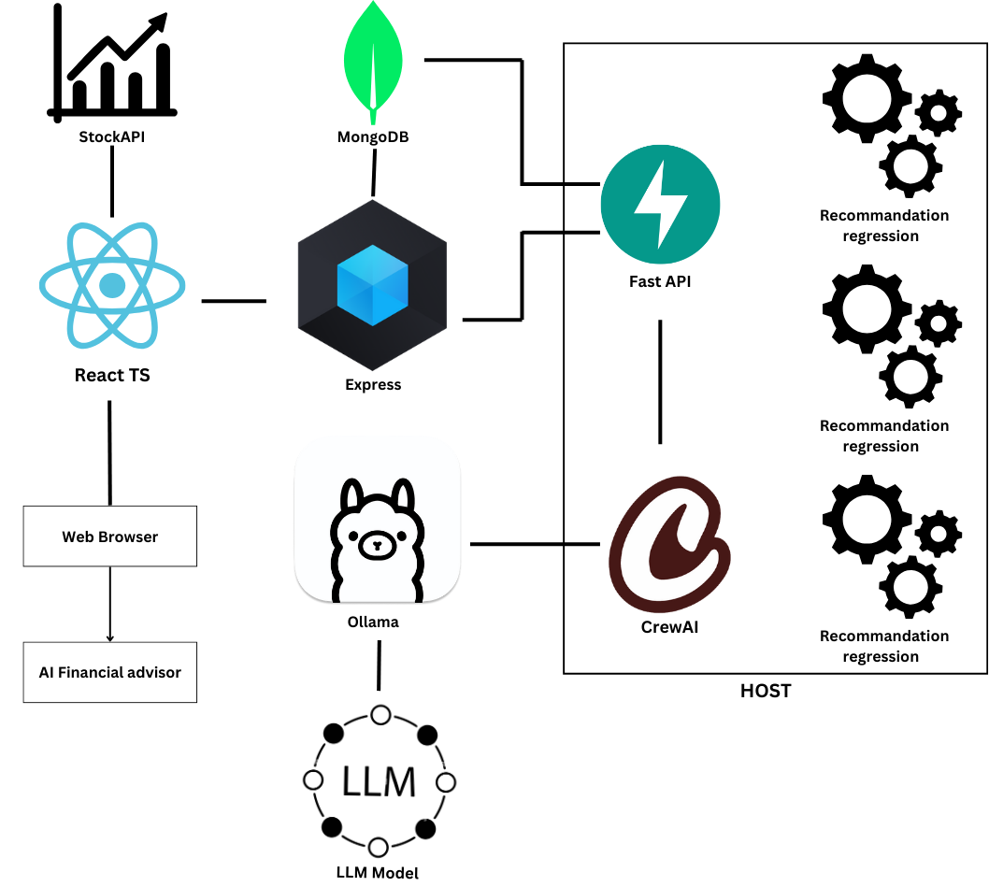

Figure 1: General system technologies scheme
4.3.2 use case
This use case diagram illustrates the key interactions between the user and the AI Financial Advisor system. Users can register by setting their username, email, password, and selecting preferred stocks, which are included as mandatory steps in the process. After logging in, users gain access to various features, including: view dashboard, view my news, recommensation request, chatbot, view about and FAQ page and contact with the developers.
Users can log out at any time, ensuring a secure and streamlined experience. This diagram emphasizes the platform’s focus on accessibility and ease of navigation for its core features.

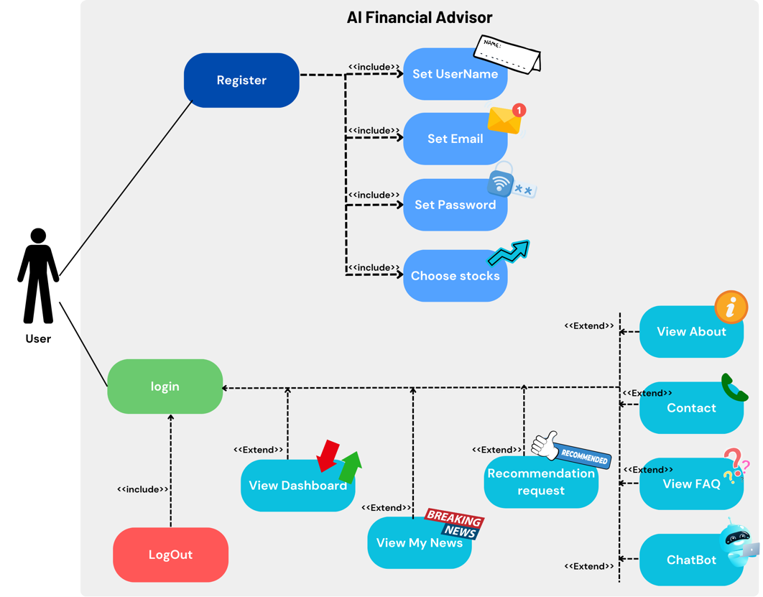

Figure 2: Use case diagram
4.3.3 Activity diagram
The following activity diagrams provide a detailed representation of two core processes within the AI Financial Advisor platform:
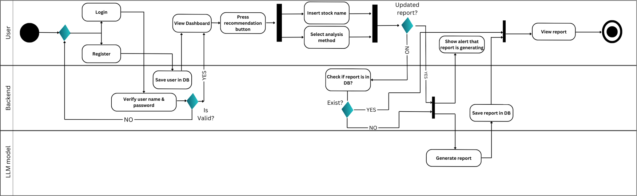
1. Recommendation Report Generation:
This diagram illustrates the steps involved in generating a stock recommendation report. It covers user input, backend data verification, and AI-driven report creation. The process includes checking whether a report already exists in the database or generating a new one, ensuring users receive accurate and up-to-date financial insights.

Figure 3: Activity Diagram- Generate Recommendation
2. Chatbot Interaction:
This diagram outlines the process of user interaction with the AI-powered chatbot. It demonstrates how user input is handled, requests are processed by the backend, and responses are generated using the LLM model. The chatbot provides quick and meaningful assistance to users, enhancing their experience with real-time advice.
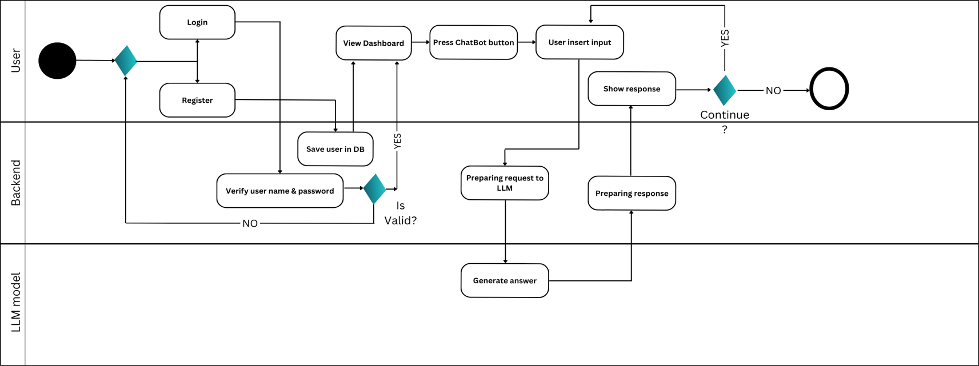

Figure 4: Activity Diagram- Interact with Chatbot

4.3.4 package diagram
The package diagram illustrates the modular structure of the AI Financial Advisor platform, showing the relationships and dependencies between its major components:
1. Client: Represents the frontend of the application, built with React. Key components include reusable UI elements (components), application context, pages, and configuration files. Dependencies flow between these packages to ensure a cohesive user interface.
2. API: Represents the backend, built with Express and FastAPI, handling business logic, middleware, utilities, and services. The features and services packages manage core backend operations, while middleware and utilities support streamlined request handling.
3. AI Integration: Handles the AI-related operations, such as the chatbot and report generation. It includes modules for configuration, routing, database interactions, and AI model dependencies (e.g., crewAI).

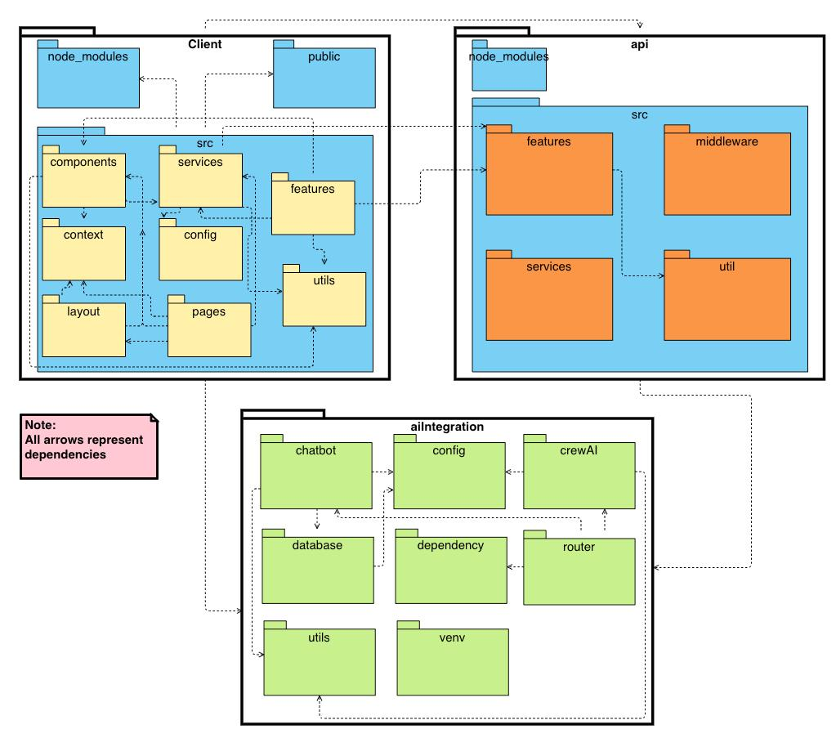
The arrows represent dependencies between the components, emphasizing how the frontend, backend, and AI integration layers communicate to deliver a seamless and functional application.

Figure 5: Package diagram

4.3 Results and conclusions
This section provides an analysis of the outcomes of our project, focusing on whether the goals defined in Phase A were achieved. It also examines how challenges were addressed, the decisions made throughout the process, and the considerations behind those decisions. The evaluation highlights the success of our efforts, as well as areas for improvement, providing a clear understanding of the project’s results.

4.3.1 Phase A goals and Outcome
Phase A goal | Outcome | explanation
Provide accurate financial advice |  | The AI model demonstrated accuracy in analyzing historical stock performance and generating insights.
Personalized reccomendations |  | The system successfully tailored advice based on user-defined preferences, risk tolerance, and financial goals.
Comprehensive analysis |  | The app successfully provides investment opportunities by generating reports that evaluate stock performance and potential. However, the user needs to manually search for a specific stock and run a report to determine whether it is worth investing, rather than receiving proactive recommendations or automated suggestions.
Enhance portfolio performance |  | During the development phase, we realized that implementing a real money management system and a personal portfolio interface was beyond our available resources. As a result, the focus shifted to providing actionable insights and reports rather than direct portfolio management.
User-focused design |  | The application features a clean, intuitive interface, making it easy for users to navigate and access personalized recommendations.
Validate prediction accuracy |  | To ensure the reliability of the models, we manually cross-checked several AI-generated reports with data from various trusted internet sources. This process confirmed that the information provided by the system was accurate and aligned with real stock performance and market trends.
Support continous improvement |  | Feedback loops and system monitoring mechanisms were implemented, allowing for iterative improvements and the refinement of AI models.
4.3.2 Challenges and decision-making considerations
Throughout the project, we encountered several challenges that required a structured approach to overcome. Our decision-making process was guided by the project’s goals, resource limitations, and the need to deliver a functional and reliable application.
When facing challenges, we prioritized understanding the core issues before proposing solutions. This often involved discussions within the team to weigh the trade-offs between different approaches. For instance, when deciding how to allocate resources, we focused on features that provided the most value to the user while staying within the project scope.
Additionally, user experience remained a central focus in our decisions. Whenever possible, we chose solutions that simplified interactions for the user, even if they required more effort on the technical side. This helped ensure the final product was intuitive and user-friendly.
Overall, our approach to challenges combined careful analysis, collaboration, and a focus on practicality.
4.3.3 Lessons learned
The project provided valuable insights into effective workflows and technical development. Our structured approach, clear goal-setting, and focus on practicality allowed us to meet many objectives, including delivering a functional system within our resource constraints. Breaking the project into manageable phases and relying on modular design helped resolve issues early.
In retrospect, we could have improved by conducting user testing earlier, as this would have provided critical feedback for refining the UI/UX. Another area for refinement was streamlining our development workflow. At times, team members worked on overlapping tasks, which led to minor inefficiencies. Establishing a more structured task assignment system earlier in the project might have made collaboration even smoother.
Key takeaways include the importance of balancing ambition with feasibility and prioritizing user feedback and automation for future projects.
As we can see from the table summarizing the Phase A goals and outcomes, we successfully met most of the project metrics set during the initial planning phase, while a few areas require further refinement.
Overall, the project achieved its primary objectives, delivering a functional application capable
of providing personalized financial advice, accurate stock insights, and a user-friendly interface.

4.4 Testing process
In this section, we outline the testing processes used to ensure the reliability and functionality of the AI Financial Advisor platform. The frontend was thoroughly tested using React Testing Library, focusing on individual component behavior, rendering, and user interactions to ensure a seamless user experience. For the AI integration and backend logic, we employed Pytest, allowing us to validate API endpoints, data processing, and error handling.
Below, a comprehensive table details the tests conducted, their descriptions, and the corresponding results. This ensures transparency and demonstrates the robustness of our testing approach.

Pytest:
Test name | Description | Output
test_chat_endpoint | Tests the functionality of the chat endpoint. | Passed
test_chat_invalid_request | Verifies how the chatbot handles invalid requests. | Passed
test_chat_unexpected_error | Simulates unexpected errors to validate error handling in the chatbot. | Passed
test_get_tools | Tests the availability and functionality of tools in the system. | Passed
test_get_stock_price_success | Confirms successful retrieval of stock price data. | Passed
test_get_stock_price_no_price | Ensures appropriate behavior when no stock price is available. | Passed
test_add_report_invalid_stock_symbol | Validates error handling for invalid stock symbols during report creation. | Passed
test_add_report_invalid_symbol | Checks the system’s response to invalid symbols when adding reports. | Passed
test_get_all_reports | Ensures that all reports can be fetched successfully. | Passed
test_get_latest_report_not_found | Verifies the behavior when a requested latest report is not found. | Passed
test_get_reports_by_stock_symbol_  success | Confirms successful retrieval of reports by valid stock symbols. | Passed
test_get_reports_by_stock_symbol_not_  found | Ensures correct handling when no reports exist for a given stock symbol. | Passed
test_get_latest_report_valid_request | Tests successful retrieval of the latest valid report. | Passed
test_get_reports_by_stock_symbol_valid | Confirms retrieval of reports by stock symbols with valid inputs. | Passed
test_get_reports_by_stock_symbol_  missing_  query | Validates behavior when required query parameters are missing. | Passed
test_analyze_report_with_invalid_report_  type | Checks the system’s response to invalid report types during analysis. | Passed
React testing library:
Test | Description | Output
Card Component | renders title and children correctly | Pass
Card Component | renders with custom styles through sx prop | Pass
Card Component | renders with ReactNode title | Pass
Card Component | renders multiple children correctly | Pass
Card Component | renders with minimum width of 200px | Pass
StocksChart Component | renders chart component with correct data | Pass
StocksChart Component | shows loading state when isLoading is true | Pass
StocksChart Component | does not show loading state when isLoading is false | Pass
StocksChart Component | renders with empty data | Pass
Article Component | renders article title | Pass
Article Component | renders publish date | Pass
Article Component | renders article image | Pass
Article Component | opens article URL in new tab when clicked | Pass
Article Component | handles null publish date | Pass
Article Component | renders with correct typography variants | Pass
FAQ Component | renders FAQ title and description | Pass
FAQ Component | renders FAQ items | Pass
FAQ Component | expands and collapses FAQ items when clicked | Pass
FAQ Component | shows correct expand/collapse icons | Pass
FAQ Component | allows multiple FAQ items to be open | Pass
TrendingCard Component | renders trending card with title | Pass
TrendingCard Component | fetches and displays trending data | Pass
TrendingCard Component | makes correct API call | Pass
TrendingCard Component | handles empty response | Pass
TrendingCard Component | limits displayed trending tickers to 5 | Pass
TrendingCard Component | formats data correctly | Pass
GainersCard Component | renders gainers card with title | Pass
GainersCard Component | fetches and displays gainers data | Pass
GainersCard Component | makes correct API call | Pass
GainersCard Component | handles empty response | Pass
GainersCard Component | limits displayed gainers to 5 | Pass
ChatInput Component | renders input field and submit button | Pass
ChatInput Component | updates input value when typing | Pass
ChatInput Component | calls onSubmit when send button is clicked | Pass
ChatInput Component | displays current input value | Pass
ChatInput Component | renders send icon in button | Pass
ChatInput Component | has correct layout styles | Pass
ChatInput Component | has full width text field | Pass
ContactPaper Component | renders all form fields | Pass
ContactPaper Component | handles input changes | Pass
ContactPaper Component | displays form values | Pass
ContactPaper Component | handles form submission | Pass
ContactPaper Component | disables submit button when form is invalid | Pass
ContactPaper Component | enables submit button when form is valid | Pass
ContactPaper Component | renders required fields | Pass
ContactPaper Component | renders email field with email type | Pass
LosersCard Component | renders losers card with title | Pass
LosersCard Component | fetches and displays losers data | Pass
LosersCard Component | makes correct API call | Pass
LosersCard Component | handles empty response | Pass
LosersCard Component | limits displayed losers to 5 | Pass
PanelCard Component | renders panel card with title | Pass
PanelCard Component | renders all card items | Pass
PanelCard Component | renders dividers between items | Pass
PanelCard Component | does not render divider after last item | Pass
PanelCard Component | handles empty data array | Pass
PanelCard Component | renders with correct styles | Pass
PanelCard Component | renders title with correct typography variant | Pass
PanelCard Component | renders all items with correct data | Pass
Messages Component | renders messages correctly | Pass
Messages Component | displays timestamps | Pass
Messages Component | renders bot avatar for bot messages | Pass
Messages Component | renders user avatar for user messages | Pass
Messages Component | renders empty state when no messages | Pass
Messages Component | preserves message whitespace | Pass
Messages Component | applies correct colors based on sender | Pass
Contact Component | renders contact form with title | Pass
Contact Component | handles form submission successfully | Pass
Contact Component | handles form submission error | Pass
Contact Component | clears form after successful submission | Pass
Contact Component | validates form before submission | Pass
Contact Component | closes snackbar after timeout | Pass

4.4.1 Results and conclusions
The testing process validated the reliability and functionality of the AI Financial Advisor platform.
Using React Testing Library, we ensured the frontend components rendered correctly, managed state effectively, and provided seamless user interactions.
For the backend and AI integration, Pytest confirmed the robustness of API endpoints, data handling, and AI-driven recommendations. All critical tests passed successfully, demonstrating the system’s ability to handle real-world scenarios.
In summary, the platform’s frontend and backend are stable and reliable, providing a smooth and efficient user experience. Further iterations may focus on extending test coverage to support scalability and performance.

5. User guide:

5.1 Nominal usage scenarios
5.1.1 Register and log in
5.1.1.1 login
When starting the application, the user will first need to sign in and fill an email and password.
In case of a new user, registretion is needed.

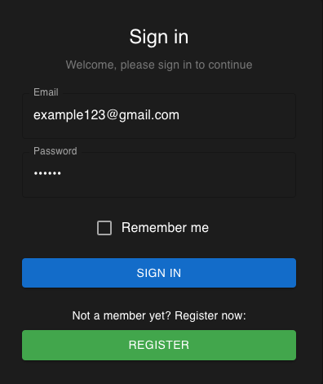
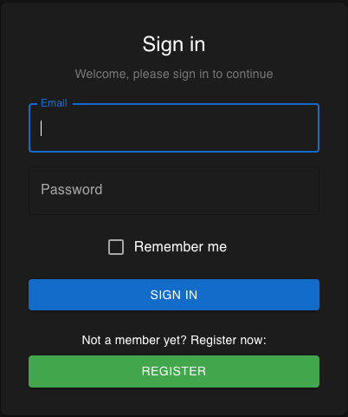

Figure 7 : sign in second part
Figure 6: sign in first part

5.1.1.2 Register
In case that the user is not a member yet, there is a need for registration. This involves entering a valid name, email address, and password. The password must meet the minimum security requirement of at least six characters. Additionally, users are required to select at least one stock to follow, which will personalize their experience within the app. Once the registration is successfully completed, the user is automatically logged into the application using their unique user ID.

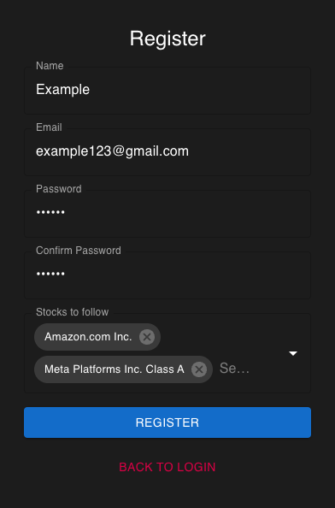
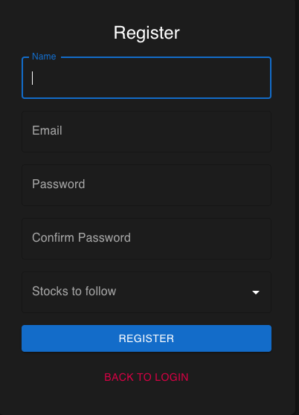



Figure 9: register second part
Figure 8: register first part

5.1.2 Dashboard
After logging in or registering, the user is redirected to the dashboard, the central hub of the app. The dashboard displays an interactive graph of the user’s selected stocks, showing key data such as open, high, low, and close values. It also serves as a navigation point, allowing users to access other pages like “My News,” “Recommendations,” “Chatbot,” FAQ, About, and Contact pages, ensuring a seamless user experience.

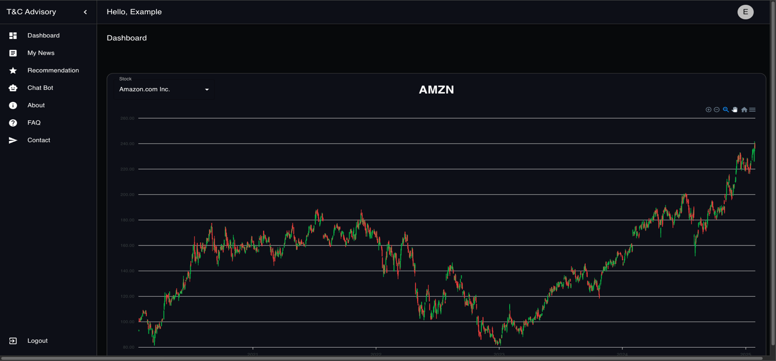
Here the user can see the stock selected during the registration

Figure 10: Dashboard

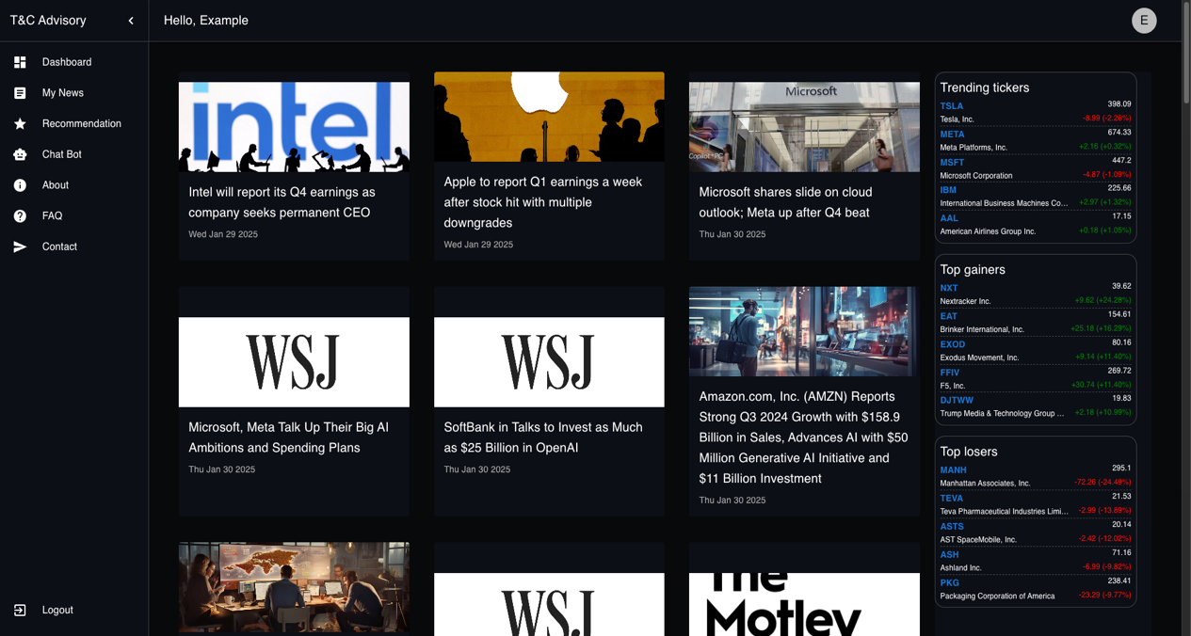
5.1.3 My news
The “My News” page keeps users informed about the latest developments related to their preferred stocks. It displays relevant news articles, ensuring users stay updated on significant market events. In addition to personalized stock news, the page features real-time trading tickers, highlighting the top gainers and top losers of the day across all stocks.

Figure 11: My news
5.1.4 Recommendation
The Recommendations page allows users to generate detailed, AI-powered stock reports based on quarterly and yearly financial data, the latest news, or both. Quarterly and yearly financial data reports analyze a company’s financial performance over the past quarter or year. Reports based on the latest news provide analysis of recent market developments, news events, and their potential impact on the stock. By selecting both, users receive a comprehensive report that combines financial performance with recent news insights for a well-rounded view.
Each report begins with a simple recommendation represented as a pie chart, categorizing the stock as Buy, Sell, or Hold, based on the AI analysis. This chart is accompanied by a short summary, offering users an immediate understanding of the stock’s potential without needing to dive into the full details. For users seeking more information, the full report includes the following:
Industry Trends and Market Position: An overview of the industry landscape and the company’s standing within it.
Valuation of the Company: Insights into the company’s current valuation compared to peers and historical performance.
Risk Factors: Identification of potential risks associated with the stock, such as market volatility, regulatory issues, or financial instability.
Company Growth: A detailed analysis of the company’s growth trajectory, including financial performance and future potential.
Summary: A concise conclusion that integrates all insights, providing users with actionable advice.
Simply enter a stock name, choose their preferred analysis method, and click “Generate Recommendation.” The Request Progress column displays all previously created reports stored in the database. If a report is already marked as “Done,” it will appear immediately for the user to review. If no existing report matches the user’s request, the system generates a new report, notifying the user that the process may take approximately 15-20 minutes.
All reports include timestamps, providing clarity on when they were created. If a user needs an updated report, regardless of whether an existing report is marked as “Done,” they can check the box labeled “I want an updated report” before generating a new recommendation. This ensures users always have access to the latest, most relevant financial insights, with the pie chart offering a quick, actionable summary at a glance.

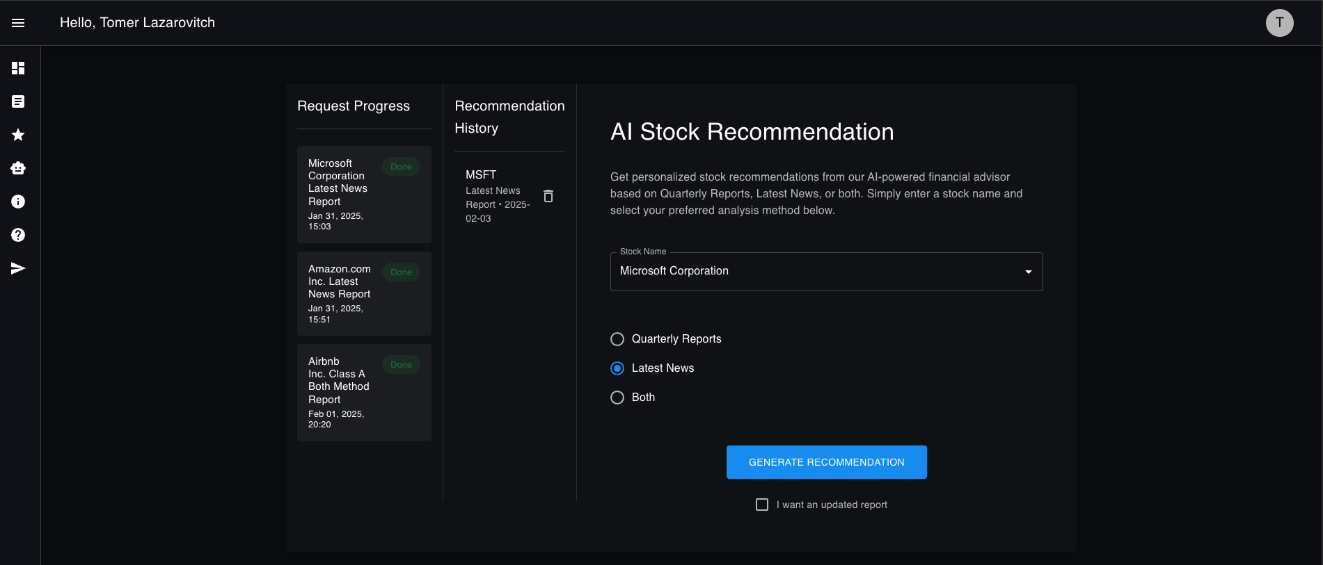


Figure 12: Generate recommendation

After clicking “generate Recommendation” the report will appear
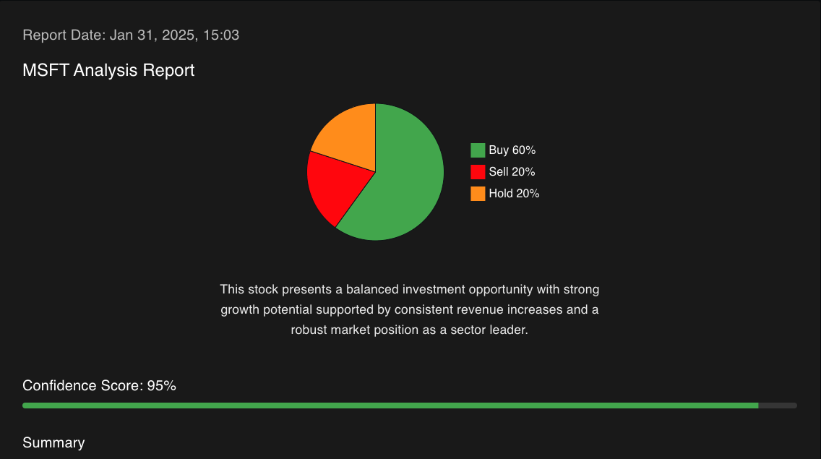

Figure 13: AI report and recommendation
*The report is much more detailed and you need to scroll down to see the rest.

5.1.5 Chatbot
The Chatbot page provides users with a conversational interface to ask questions or seek advice about their stocks and investments. Powered by advanced AI, the chatbot is designed to offer quick and accurate responses, simplifying complex financial concepts and guiding users through their inquiries.
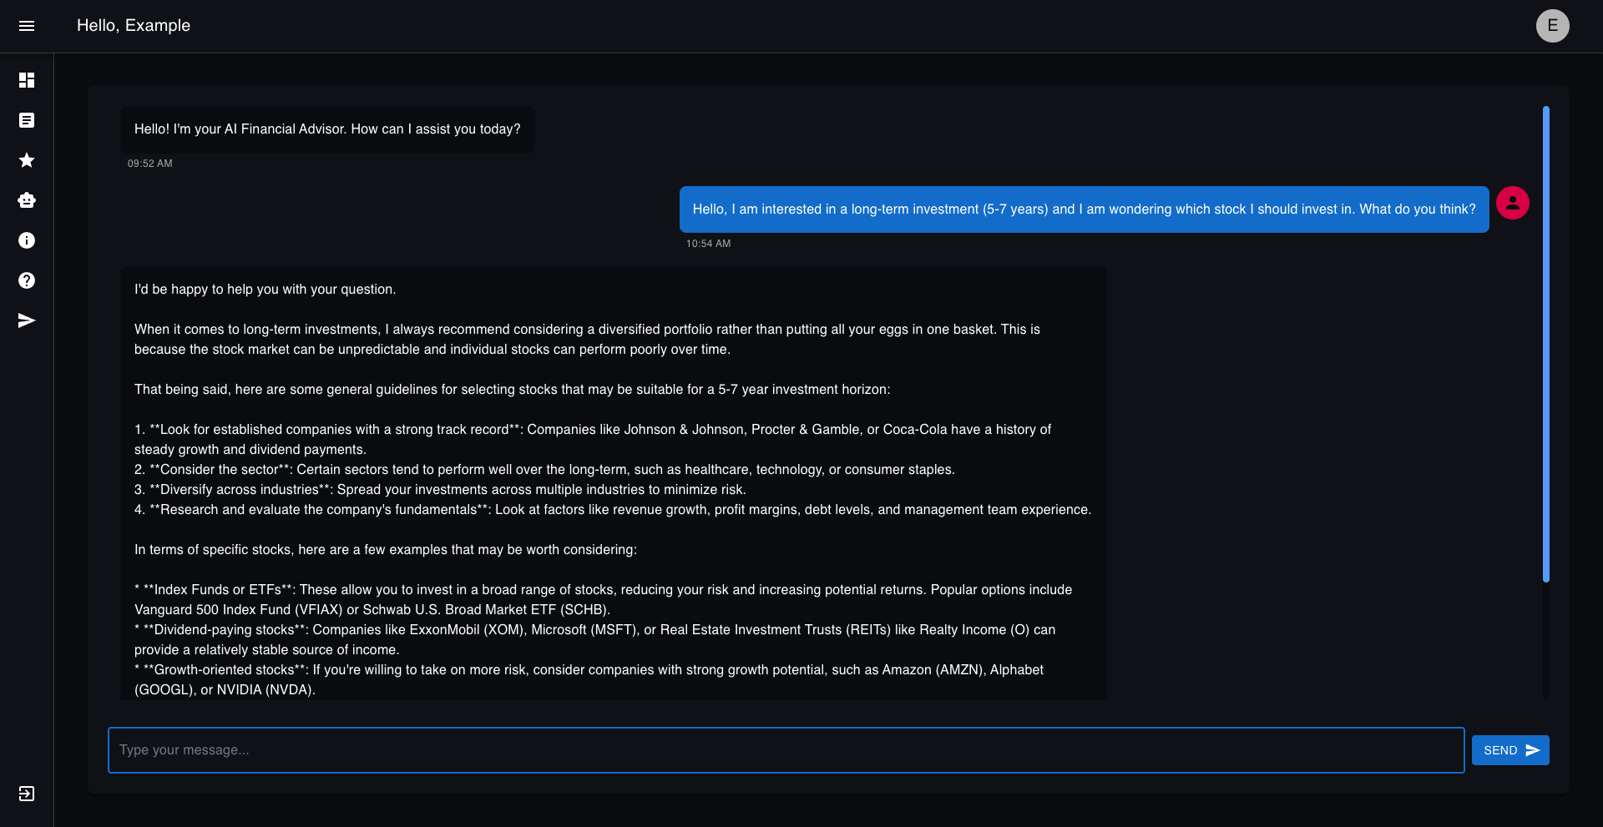

Figure 14: Chat bot

5.1.6 About
The About page provides users with an overview of the application, explaining its purpose, features, and the technology behind it.
Additionally, the page includes a link to the project’s GitHub repository, allowing users to explore the source code and learn more about the development process. For those interested in connecting with the development team, the page also features LinkedIn links to the profiles of the developers.

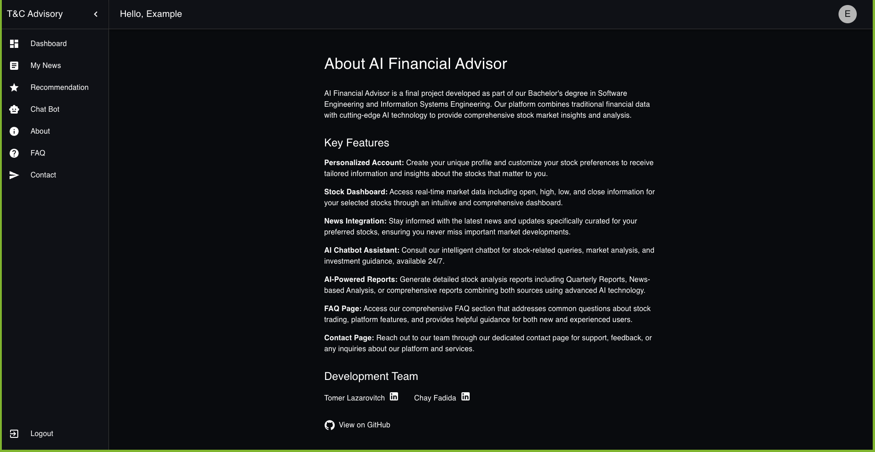

Figure 15: About page
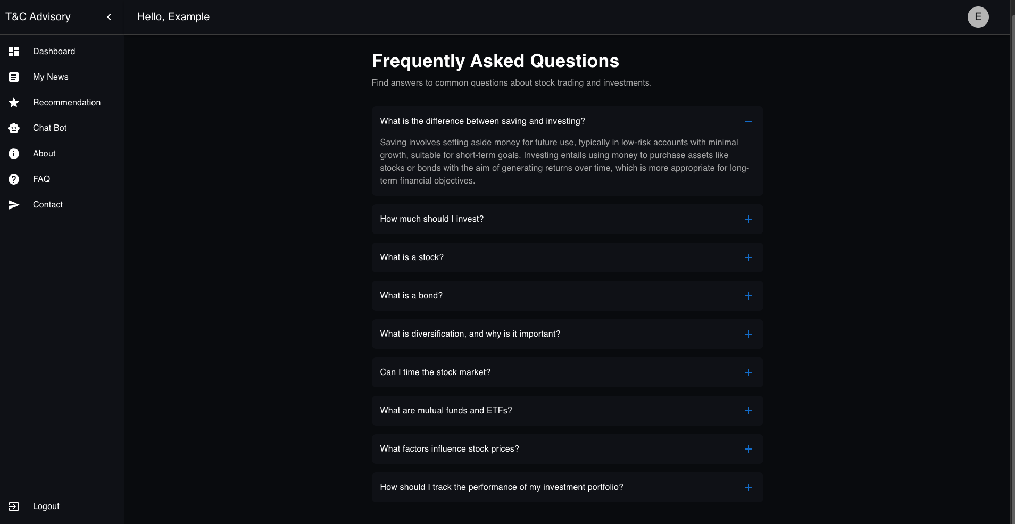
5.1.7 FAQ
The FAQ page is a resource for users to find answers to general stock-related questions. It provides insights into common financial terms, stock market concepts, and investment strategies, making it easier for users to understand the world of stocks.

Figure 16: FAQ page

5.1.8 Contact
The Contact page provides users with a straightforward way to connect with the development team. This page is designed to handle user feedback, bug reports, and general inquiries about the application. To send a message, users are required to fill out a simple form that includes their name, email address, and a message field where they can describe their concern, suggestion, or question in detail.
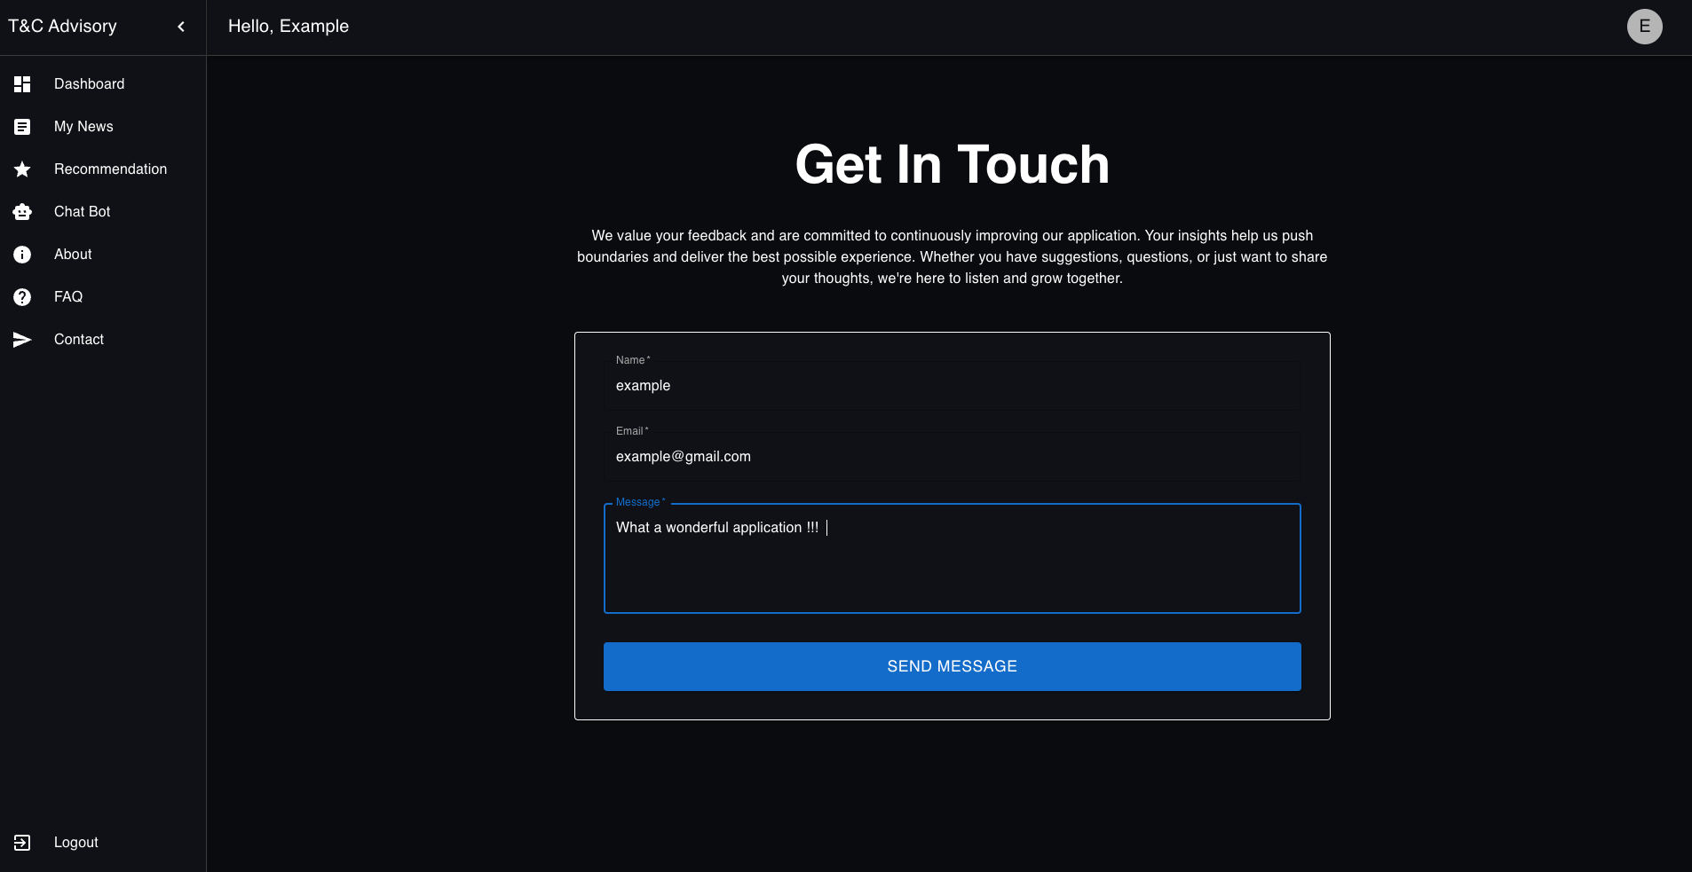

Figure 17: Contact page

5.1.9 Edit profile
The Edit Profile feature allows users to update their personal information and preferences to ensure their experience remains tailored to their needs. Users can change their name and modify the list of stocks they follow. However, the system requires that users follow at least one stock at all times.

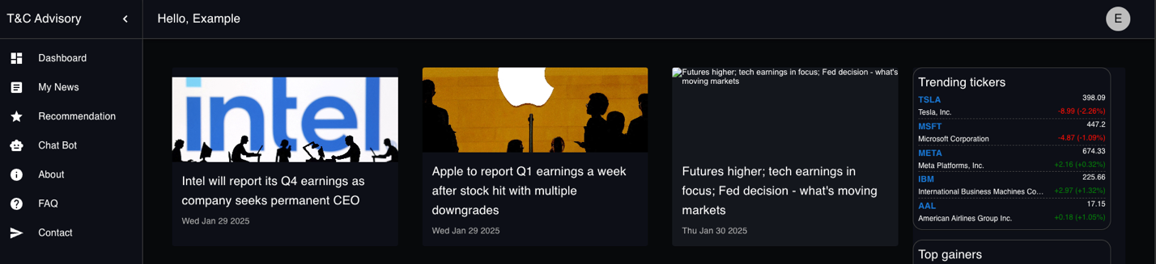
Figure 18:edit profile part 1

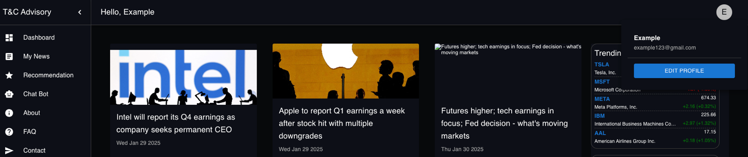

Figure 19:edit profile part 2

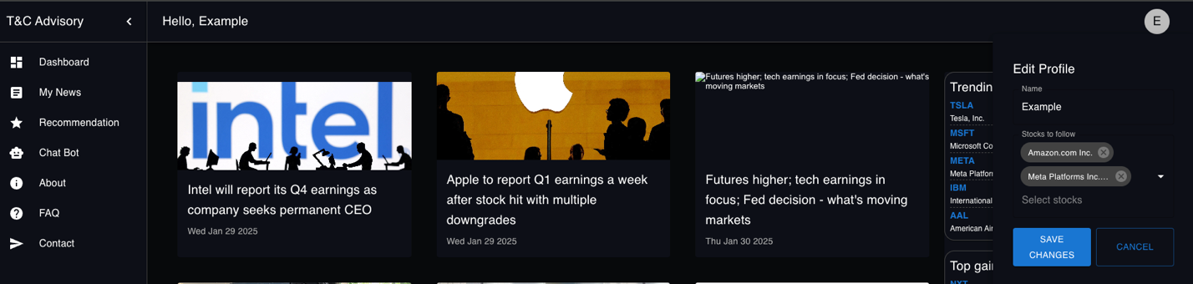
Figure 20:edit profile part 3

6. Maintenance guide:
6.1 Operation Instructions:
This guide will walk you through the operational process of the system, ensuring a smooth and effective user experience.
6.1.1 Install Ollama
Download and install the Ollama program on your computer. This tool is essential for managing and integrating the AI model used by the application.
6.1.2 Choose and download your AI model
Select the AI model that you want the application to integrate with. We recommend using the llama3.2-vision:11b model for the recommendation and 0xroyce/plutus:latest for the chatbot, but you can choose any model that fits your needs and resources.
To download the model:
1. Open your terminal.
2. Run the following command:
ollama pull <model name>
* Replace <model name> with the desired model’s name (e.g., llama3.2-vision:11b).

6.1.3 Install Python dependencies
Navigate to the aiIntegration folder, where you’ll find the req.txt file. Install the required dependencies using the following command:
pip install -r req.txt
6.1.4 Install dependencies for the API
Navigate to api folder and run:
yarn install
6.1.4 Install dependencies for the client
Navigate to client folder and run:
yarn install
6.1.5 Configure Environment Files
In each of the following folders:
- aiIntegration
- client
- api
Locate the env.example file.
Create a new .env file in each folder and populate it with the required secrets or generate your own. This configuration is necessary to connect the application components.
A crucial part of this setup is obtaining an API key and host from RapidAPI, which the system uses to fetch stock-related data. Users must register on the RapidAPI website, locate the relevant financial data API (YH Finance), and retrieve the required credentials (API key and host). These values must then be copied into the .env files to enable seamless integration with external services.
Important Note: We utilized a free trial version of the API, which is time-limited. If the free trial expires or an API-related error occurs, users may need to create a new RapidAPI account, generate a new API key, and replace the outdated key in the .env files. This ensures continued access to the necessary data services and prevents disruptions in application functionality.
6.1.6 Run the AI integration service
Navigate to the aiIntegration folder and run the following command to start the Python AI service:
python app.py
6.1.7 Run the API server
Navigate to the api folder and start the API server with:
yarn start
6.1.8 Run the client application
Navigate to the client folder and start the client application with:
yarn start

7. Conclusions:
The development of the AI Financial Advisor successfully combined artificial intelligence and advanced analytics to create a powerful yet accessible tool for stock market analysis. Through a structured approach, we designed and implemented a web application that provides personalized stock recommendations, real-time financial data, and AI-driven insights to help users make informed investment decisions.
The project involved integrating multiple technologies, including FastAPI, React, MongoDB, and AI models, ensuring a seamless and efficient user experience. Throughout the process, we tackled challenges such as data integration, AI model implementation, and user interaction design while focusing on scalability and usability.
This project serves as a strong foundation for further development, with opportunities to enhance automation, refine AI-driven recommendations, and expand market data analysis. Ultimately, the AI Financial Advisor empowers users with the knowledge and tools needed to navigate the stock market with confidence.

8. References:
Brown, T., Mann, B., Ryder, N., Subbiah, M., Kaplan, J., Dhariwal, P., & Neelakantan, A.
(2020). Language Models are Few-Shot Learners

Vemula, A., Kumar, R., Liu, Y., & Cohen, W. W. (2023). Learning Personalized Retrievers for Search-Based Question Answering.

Goodfellow, I., Pouget-Abadie, J., Mirza, M., Xu, B., Warde-Farley, D., Ozair, S., ... & Bengio, Y. (2014). Generative adversarial networks. Advances in Neural Information Processing Systems, 27, 2672-2680.

Ramírez, S. (2018). FastAPI: A Modern Web Framework for Building APIs with Python 3.6+ Based on Standard Python Type Hints.

MongoDB: A flexible, scalable database solution. MongoDB Documentation.
Heaton, J., Polson, N., & Witte, J. (2017). Deep learning for finance: Deep portfolios. Applied Stochastic Models in Business and Industry, 33(1), 3-12.

Hochreiter, S., & Schmidhuber, J. (1997). Long short-term memory. Neural Computation, 9(8), 1735-1780.

Brown, T., Mann, B., Ryder, N., Subbiah, M., Kaplan, J., Dhariwal, P., & Neelakantan, A. (2020). Language Models are Few-Shot Learners.
Vemula, A., Kumar, R., Liu, Y., & Cohen, W. W. (2023). Learning Personalized Retrievers for Search-Based Question Answering.
Goodfellow, I., Pouget-Abadie, J., Mirza, M., Xu, B., Warde-Farley, D., Ozair, S., ... & Bengio, Y. (2014). Generative adversarial networks. Advances in Neural Information Processing Systems, 27, 2672-2680.
Ramírez, S. (2018). FastAPI: A Modern Web Framework for Building APIs with Python 3.6+ Based on Standard Python Type Hints.
MongoDB: A flexible, scalable database solution. MongoDB Documentation.
Heaton, J., Polson, N., & Witte, J. (2017). Deep learning for finance: Deep portfolios. Applied Stochastic Models in Business and Industry, 33(1), 3-12.
Hochreiter, S., & Schmidhuber, J. (1997). Long short-term memory. Neural Computation, 9(8), 1735-1780.

